**Student Written Assessment (Airport Maintenance Assignment (Part 2))**

|  |  |  |  |
| --- | --- | --- | --- |
| **Business Unit/Work Group** | IT Studies | | |
| **Qualification Code** | National Code: ICT50715 | **Qualification Title** | Diploma of Software Development |
| **Unit Code/s** | ICTDB502 | **Unit Title/s** | Design a Database |
| **Assessment Task Title** | **5DD Airport Maintenance Assignment (Part 2)** | | |
| **Student Name** | Submit your solution via your LEARN account | **Student SIS ID** | Submit your answers via your LEARN account |
| **Assessor Name** | You have been added to a LEARN group which defines your assessor. This is normally your Course Registration Number (CRN) lecturer. | **Date** | 2019 Semester 1 |

|  |  |
| --- | --- |
| **Student Guide for Practical Assessment** | |
| **Overview of Assessment** | This assessment will require you to complete several sections requirements for the Southern Airport Maintenance database. Each section has multiple parts require you to complete.  In this assessment you will cover the following topics:   * Design the data structures (object types and table of object) * Design queries based on the requirements (database object methods) * Design output screen to fulfill user query (use JDBC connection to Oracle in AWS – Netbeans)   The assessment contains 3 sections and you will submit the whole solution by the assessment due date. |
| **Task/s to be assessed** | This part of the assignment requires you to design a logical data structures using the Oracle OODBMS object types, table of object, object methods & using a java program to execute the object method to fulfill user query on the summary result. It also includes some research exercise to address the database theory concepts. The following pages will define the specific tasks you need to complete. |
| **Time allowed** | You have the whole course duration to complete this exercise. You should adhere to this date so that you get a balanced work load throughout the semester.  The submission date is provided in the LEARN course and summarized in the Assessment Submissions topic in LEARN. |
| **Location** | You can complete this assessment during your practical sessions and at home. |
| **Decision making rules** | To receive a satisfactory outcome for this assessment you must complete all tasks and parts correctly. |
| **Assessment conditions** | You must use the provided UML model, Java coding practices (in 4JAB) in completing this assessment. |
| **Resources required** | None. |
| **Results/Re-assessment** | You will be provided feedback for each task of the assessment and be given the opportunity to resubmit with any required corrections only once. |
| **Submission Instructions** | The exercise can be found in the Assessment Submission Topic on LEARN. Your solution is required to upload to LEARN. |

**5DD Airport Maintenance Assignment (Part 2)**

**Scenario:**

# This part of the assignment is the continuation of the assignment (Part 1). Please refer to the Assignment (Part 1) document for information on the case scenario.

For this Assignment (Part 2), you will have an account in the **Oracle database** in Amazon Web Services (AWS) for the Assignment 2. Your user name should be your firstname attached with your First character of the last Name plus **Ass2**. e.g. For John Smith his user name will be:

Student: John Smith

Oracle user name :  **johnSAss2**

The password : John Smith’s Student ID

The Oracle 11g database server has a System ID (**SID**) called **xe** and it is located in the AWS VM server with a public IP address of **35.166.130.72**. It uses the server port no. 1521.

The Southern Airport maintenance manager wants to implement a prototype of a simplified version of the database using the Oracle OORDBMS extension techniques for testing purposes.

Management prefers to keep the information as generic as possible. He confirmed the following business rules:

* A sub-model is a kind of model.
* A passenger aircraft is a kind of sub-model.
* A cargo aircraft is a kind of sub-model.
* Each airplane may either belong to a passenger aircraft or a cargo aircraft.
* Each airplane may have 0, 1 or many airplane.
* Each air plane must belong to one and only one airline.
* Each airline may have 0, 1 or many airplane.

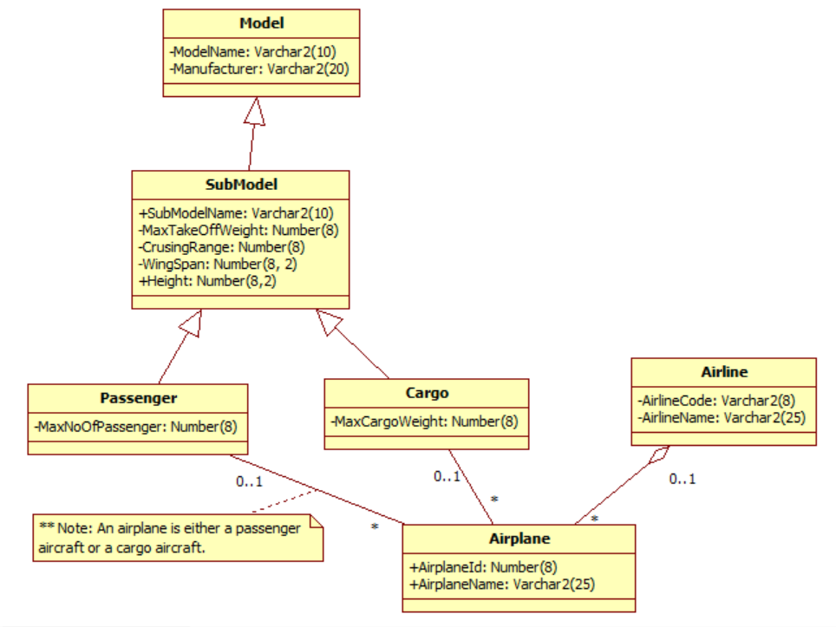

**Requirements:**

Given the Airport Maintenance Scenario (See **5DD_Airport_Maintenance_Assignment (Part 2)_180203.docx**), you are required to carry out the following tasks:

**SECTION A. (Create object type and table of objects. Set up object ref)**

1. Develop the database schema for implementing the model in the Oracle OORDBMS. You **must** create the table using user-defined object types.

i.e. Make use of the super-type / sub-type (“**is-a**”), **REFs** and/or **nested table** (i.e. or “**has-a** / **whole-part**”) features of Oracle.

For simplicity, you only require to define the following object types:

Airline, Airplane, Model, SubModel, Passenger SubModel, Cargo SubModel

* Create the above six Object Types (**Note: you may use either **REF** or the nested tables.) However, it is recommended to use the REF for association relationships.
* Create Tables for their **object type**
* Assign the primary keys for each object table.

**SECTION B. (Create database object methods and Insert object data)**

* Create a method in the appropriate object type to display how many airplanes are owned by each airline.
* Insert record statements (3 records for each table that support the testing of your queries)
* Run the database method with your test data. Capture the screen shot for successful execution.

**SECTION C. (Run the database object method - Netbeans)**

Write a Java program (using Netbeans) to retrieve and display how many airplanes are owned by each airline. (i.e. Use JDBC connection).

1. Design your input layout and also design your output layout. You may use a prototyping tool or even use MS-Word to show the input and output layouts before you write the Java code. Capture the screen shots for your design.
2. Write the java code to run the method designed in SECTION B and display how many airplanes are owned by each airline. (i.e. Use JDBC connection). Capture the screen shots to show successful execution of your progrem.

For submission, you must submit a zip file with the scripts & screen shots to **Moodle** for marking. The AWS VM server is for testing your codes. The Oracle server will be deleted at the end of it’s useable life span. Therefore, all submission must be uploaded to Moodle.

**SECTION D. (Merit component – 1 point)**

1. Map the class diagram into **relational data structures (i.e. relational tables)**. Make sure that you indicate the **attributes, primary key** and **foreign keys** of each table.

Assume that the **SubModel** class is **abstract** and the child classes are **mandatory**. The relationship between the **Passenger** and the **Cargo** is **non**-**disjoint**.

**(0.5 marks)**

1. In rational database design, all designs must normalize the tables to at least 3NF. However, if an organization would like to adopt the Oracle OORDBMS data structures, as a database designer do you still need to follow the guidelines to normalize all tables to at least 3NF? Your answer should support with reasons why.

**(0.5 marks)**